THE STANDING ORDERS OF THE NATIONAL ASSEMBLY
PART XIX – PUBLIC BILLS

A “Private Bill” means any Bill which is intended to affect or benefit some particular person, association or corporate body;
A “Public Bill” means a Bill which is intended to affect the public generally, or a section of the public;

Introduction of Bills
S114. One or more Members, or a Committee, may submit to the Speaker a legislative proposal for introduction in the House together with a memorandum setting out the objectives of the proposal and the matters specified in Standing Order 117(Memorandum of Objectives and Reasons)
(1A) Where jointly proposed, the members shall include
- The name of the main sponsor of the proposal, who shall be the Member in Charge of the Proposal in the House; and
- The names of the co-sponsors of the proposal, in alphabetical order.
(2) The Speaker shall refer the legislative proposal and the memorandum to the Clerk
who shall consider the legislative proposal, draft it in proper form where necessary and submit it to the Speaker with comments on—
- Whether the legislative Proposal affects the counties; if yes if it is a special or ordinary Bill
- Whether the proposal is a draft money Bill
- Whether the proposal conforms to the Constitution and law on format and style.

(3) Upon receiving the proposal,
- If the proposal is NOT a money Bill – The Speaker shall direct it to be referred to the relevant Departmental Committee for pre-publication scrutiny (where not sponsored by a committee)
  - Where Sponsored by the Committee, the Speaker shall direct that the proposal be published into a Bill
- Where it IS A DRAFT MONEY BILL the proposal will be referred to the Budget and Appropriations Committee after taking on the views of the CS responsible for finance.
Process on 114(4-8).

Speaker to exempt certain legislative proposals
S114A. (1) The Speaker may exempt a legislative proposal from the provisions of Standing Order 114 (Introduction of Bills) – on specific grounds set out in this section.

Printing of amending provisions
115. Where a Bill seeks to amend any provision of an existing Act, the text of the relevant part of such provision shall be printed and supplied as part of the Bill which is availed to Members, unless in the opinion of the Speaker, the amendment is formal, minor or self-explanatory.

DRAFTING RULES
116. Enacting formula
Every Bill shall contain, as the enacting formula, the words “Enacted by the Parliament of Kenya.”

117. Memorandum of Objects and Reasons
Every Bill shall be accompanied by a memorandum containing:
(a) a statement of the objects and reasons of the Bill;
(b) a statement of delegation of legislative powers and limitation of fundamental rights and freedom, if any;
(c) an indication whether it concerns county governments; and
(d) a statement of its financial implication and if the expenditure of public moneys will be involved should the Bill be enacted, an estimate, where possible, of such expenditure.

118. Provisions on delegated powers
Every Bill that confers on any State organ, State officer or person the authority to make provision having the force of law in Kenya in terms of Article 94(6) of the Constitution shall contain a separate and distinct part of the Bill under the title “Provisions on Delegated Powers” in which shall be expressly specified—
(a) the purpose and objectives for which that authority is conferred;
(b) the limits of the authority;
(c) the nature and scope of the law which may be made; and
(d) the principles and standards applicable to the law made under the authority.

Limitation of fundamental rights and freedoms
119. Every Bill that contains a provision limiting a right or fundamental freedom in terms of
Article 24(2) of the Constitution shall contain separate and distinct provisions—
(a) clearly expressing the specific right or fundamental freedom to be limited; and
(b) the nature and extent of that limitation.

- PRE- PUBLICATION SCRUTINY
- MAIN STAGES IN THE LEGISLATIVE PROCESS
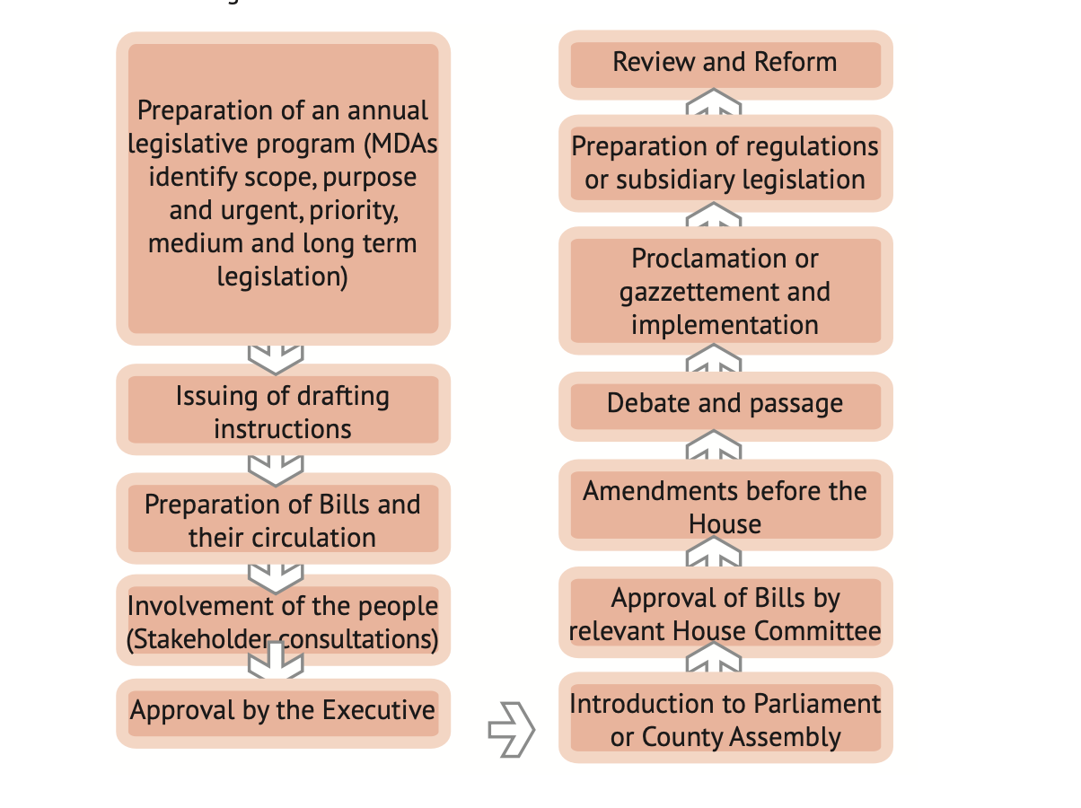

- STAGES OF A BILL BEFORE ASSENT (KLRC GUIDE)

S124. Not more than one stage of a Bill to be taken at the same sitting
These stages must be undertaken consecutively and not more than one stage of a Bill may be taken at the same sitting without the leave of the House.

In Parliament, a Bill passes through the following stages:

- PUBLICATION AND CIRCULATION
A Bill is published in a special or supplementary issue of the Kenya Gazette that may be released occasionally. The purpose of publication is to notify the public and invite representations through the elected Members or direct submission of memoranda and petitions.

- FIRST READING
This is intended to draw the attention of the Members and the public to the Bill. At this stage, the Bill may be referred to the relevant Sectorial Committee.

- SECOND READING
The Mover introduces and outlines the main purpose and objectives of the Bill including the details. Members discuss the Bill and the views of the Mover together with the report of the Sectoral Committee. At the end of the Second Reading, the only amendment that could be made is to defer its Second Reading for six months, which is literally, “killing the Bill”.

- COMMITTEE OF THE WHOLE HOUSE
At this stage the Bill is considered clause by clause. Members may propose amendments but no amendment is permitted if it implies a direct negative of the original proposal, or elimination of its main purpose/ objective. The correct way of expressing a contrary opinion is by voting against the Motion.

- REPORT STAGE
The Committee informs the House sitting in Plenary(absolute) of their consideration of the Bill.

S134. Report of Progress May be requested any member and the Chairperson shall report progress to the House and shall seek leave to sit again, and a day for the resumption of the proceedings shall be determined.

S136.A Recommittal Procedure
1) a member who desires to amend or delete a provision of the bill or introduce a new provision in the bill, may propose an amendment to add, at the end of the motion for agreement with the committee
2) If the amendment to the motion for agreement with the committee is agreed to, the bill shall stand so re-committed and the house shall either forthwith or after shall create a new committee to consider the re-committed matter.

S137. Procedure on Bills reported from Select Committees

- THIRD READING
Members may again debate the principles of what is already in the Bill but further amendments should not be proposed, except to defer its Third Reading for six months – “killing the Bill.”

140. Withdrawal of Bills
- Either before the commencement of business or on the Order of the Day for any stage of the Bill being read, the Member in charge of a Bill may, without notice, claim to withdraw a Bill.
- If the Speaker is of the opinion that the claim is not an abuse of the proceedings of the House, the Speaker shall direct that the Bill shall be withdrawn.
(2A) A Bill under Standing Order 114A(1)(b) may only be withdrawn with the leave of the Speaker.
- A Bill that has been withdrawn may subject to Standing Order 114 (Introduction of Bills) and re-publication be introduced again.
- If a Member in charge of a Bill desires to withdraw a Bill before it is introduced in the House, the Member shall, in writing specifying the reasons for the withdrawal, notify the Speaker of the withdrawal and paragraph (3) shall apply to such Bill.

THE PROCESS AT THE COUNTY LEVEL
Same as the Parliamentary Level

I. PUBLICATION AND CIRCULATION
A Bill is published in a special or supplementary issue of the Kenya and County Gazette that may be released occasionally.

